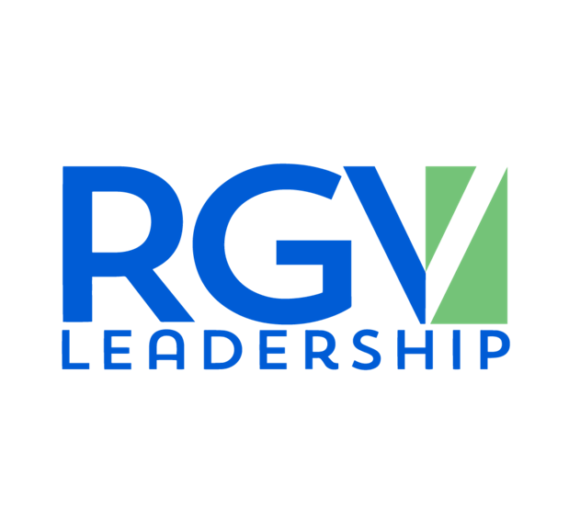

Dear RGV Leadership Applicant,

The RGV Partnership was established in 1944 to engage influencers, decision-makers, and policymakers to advance the prosperity of the Rio Grande Valley. In 2014, the Board of Directors launched the RGV Leadership program to engage and educate leaders on the importance of collaboration and engagement across our four-county region.

The RGV Leadership program will begin its 11th annual 9-month educational program, promoting collaboration and discussion on the region's most pressing challenges and opportunities.

# Program and Objectives

RGV Leadership strives to fulfill the following objectives:

* Build long-lasting relationships with leaders from across the RGV
* Engage class members with elected officials and stakeholders in a leadership position
* Have a deeper understanding & appreciation of the RGV's challenges and opportunities
* Engage in a group project - with a formal presentation at the end of the program
* Continued relationship with the RGV Partnership after graduation and Alumni events

# Time Commitment

Your time commitment to this program is essential and timely attendance is required. These will provide a successful and fulfilling experience. The program begins with an orientation retreat in South Padre Island that requires one (1) overnight stay. Your meals and hotel are included in the tuition fee.

Retreat is scheduled to take place on Saturday, September 61h, and Sunday, September 7th 2025.

After the retreat, you will be required to attend full-day sessions once a month, which will be on the second Friday of each month.

# Tuition

RGV Leadership is offered to participants at $2,000 in tuition for RGV Partnership members and

$2,500 for non-members. Non-members will receive one year of membership with acceptance into the program. The tuition includes all program materials, class shirts, snacks, meals, overnight accommodations during the retreat, and some transportation Tuition must be paid in full on or before **August 29, 2025** in order to attend the retreat and participate in Class XI.

Thank you,

Deborah L. Cordova,

RGV Leadership Class Chair

**Class XI**

**Application Deadline: July 11, 2025**

## PERSONAL DATA

First Name: Last Name:

Preferred Name: __________________________ DOB: Month/Day only: _________________

Present Employer:

Position/Title: Years with Employer:

Business Address:

Business Phone: Email:

Home Address:

Personal Phone: Years in the RGV: _

Dietary Restrictions: ____________________________________________________________________

Emergency Contact: _______________________ Emergency Number: __________________________

Polo Shirt Size: _______________________

Education (Please include name of school, dates, and degree/major):

## EMPLOYMENT HISTORY:

Please list in reverse chronological order.

Employer Title Dates Employed

## ORGANIZATIONS AND ACTIVITIES:

Please list in order of importance to your community, civic, professional, business, social, athletic, and other organizations of which you have been a member. (Add extra pages if additional spaces needed)

Organization Dates Highest Official Position held

## COMMUNITY INVOLVEMENT

What community involvement are you most proud of?

Identify any special honors or awards you have received.

## GENERAL

Why do you think you would make a good candidate for Rio Grande Valley Leadership?

In your opinion, what are the most pressing challenges facing the Rio Grande Valley today?

Why do you believe these challenges persist?

What do you hope to gain from your Rio Grande Valley Leadership experience?

## APPLICANT AGREEMENT

### Minimum of two letters of recommendation must be submitted. One of those letters must be submitted by your current employer.

Rio Grande Valley Leadership is a 9-month program which includes a retreat in South Padre Island that takes place on Saturday, September 6th and Sunday, September 7th, 2025. Saturday night hotel accommodations are included in your tuition. Retreat attendance at the retreat is mandatory for all class participants.

Following the retreat, the remaining 8 assemblies will consist of full-day sessions on the 2nd Friday of each month. The sessions will be hosted across our four-county region. Each session will include group discussions and an opportunity to work on an assigned team project.

Missing the initial retreat or more than 2 sessions during the program will automatically terminate your enrollment unless RGV Partnership Core Committee determines otherwise at its sole discretion. Three late arrivals or early departures, or combination of the two, will be cause for automatic dismissal unless RGV Partnership Core Committee determines otherwise at its sole discretion.

Electronic devices must be on silent mode during meetings.

### I have read and understood all the above and hereby submit my application to Rio Grande Valley Partnership Leadership.

Applicant’s Signature Date

**EMPLOYER/ORGANIZATION AGREEMENT** (must be signed if applicable)

This application has the approval of this applicant’s employer, which includes the time required to participate in the program.

Employer’s Signature Date

## TUITION

Tuition is $2,000 for members and $2,500 for non-members, which covers program costs for all sessions, including the Graduation Ceremony and Retreat.

## SUBMISSION

Please submit this completed application, two letters of recommendation, a headshot, and a copy of your driver's license or identification card to the following:

**Rio Grande Valley Leadership**

[rgvpartnership@gmail.com](mailto:rgvpartnership@gmail.com)